Calibration User Manual V0.01
Hardware setting
1,come into image quality,choose “RAW”and “—”
2,manual focus
3，supports cannon 7D and 70D only

1.Initializer
1, calibration mode : Full-screen calibration , Manual calibration

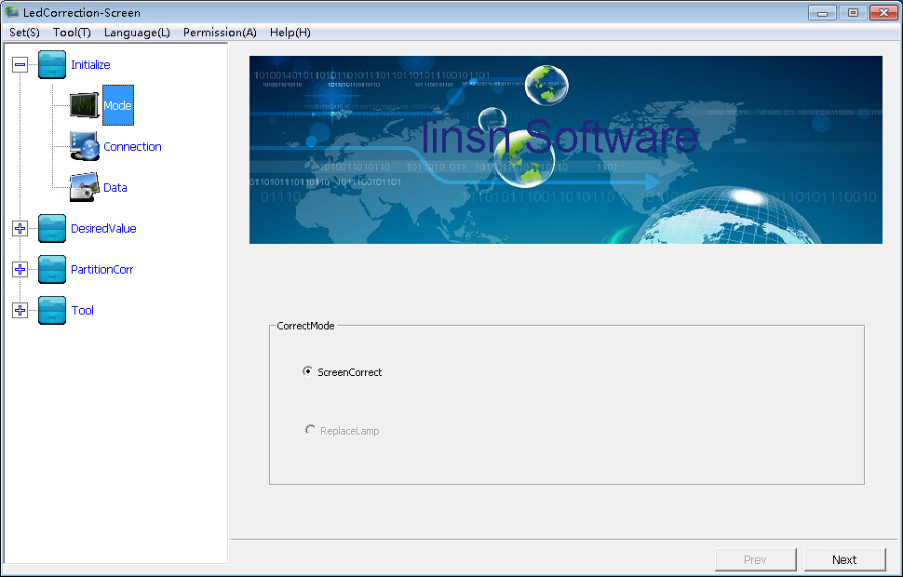
2.Online control
A, Local calibration : standalone calibration , need to keep the parameter( COM port, frequency, resolution) same as the setting of sending card .
B,Online calibration: two computers connected to the internet , the first computer connected to the screen , the second computer controlled the first computer to calibration by internet
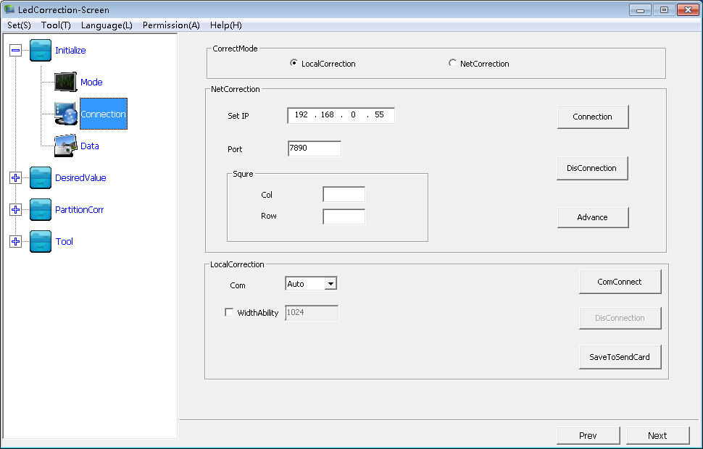
3. calibration data :
A, More than one receiving cards need to load the connection file
B,Fill in the resolution( width and the height) of the screen
C,Load the calibration file ( RVS)
D,The default directory would be empty each time before a new calibration ( suggest saving the calibration data to the custom directory)
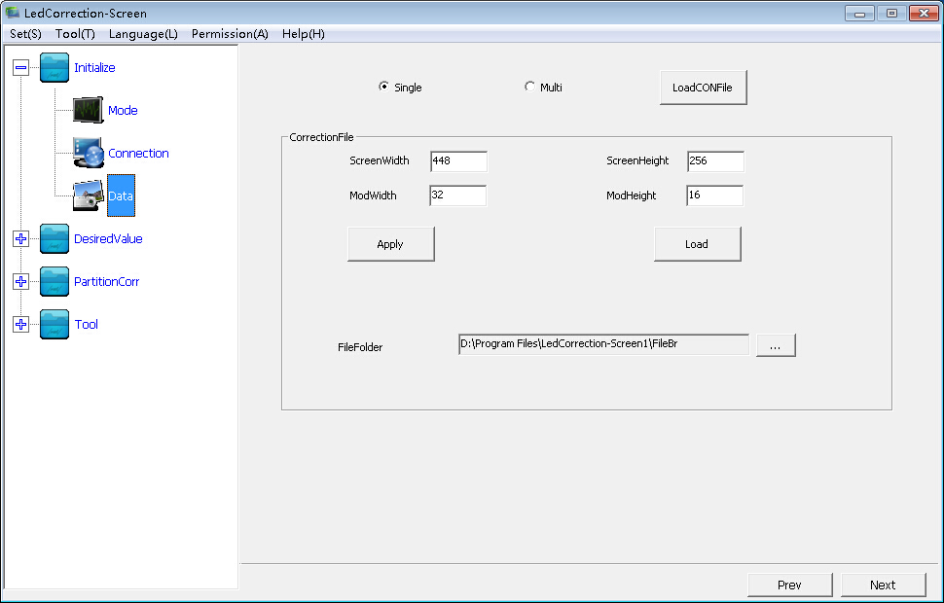
2.Calibration type : 1, brightness calibration , can set the expected brightness by clicking “next”
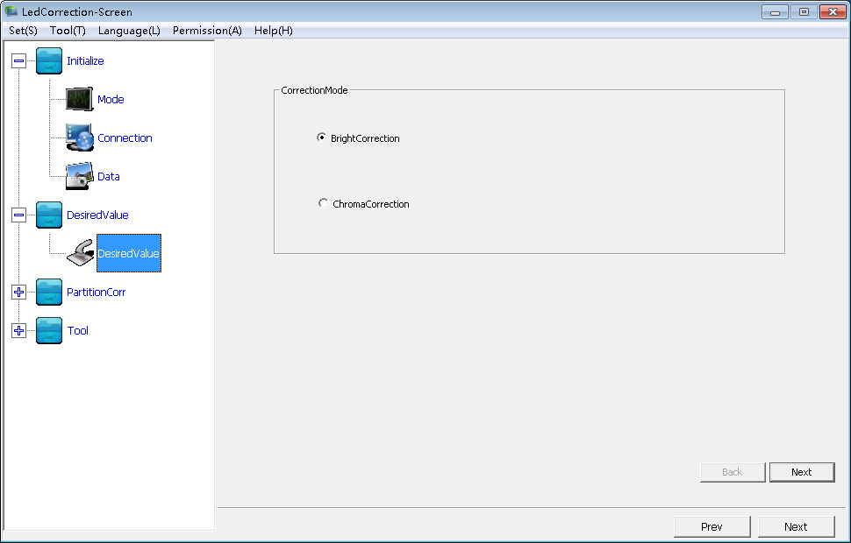
2, Colour calibration ,can set colour conversion of multiple batch cabinets
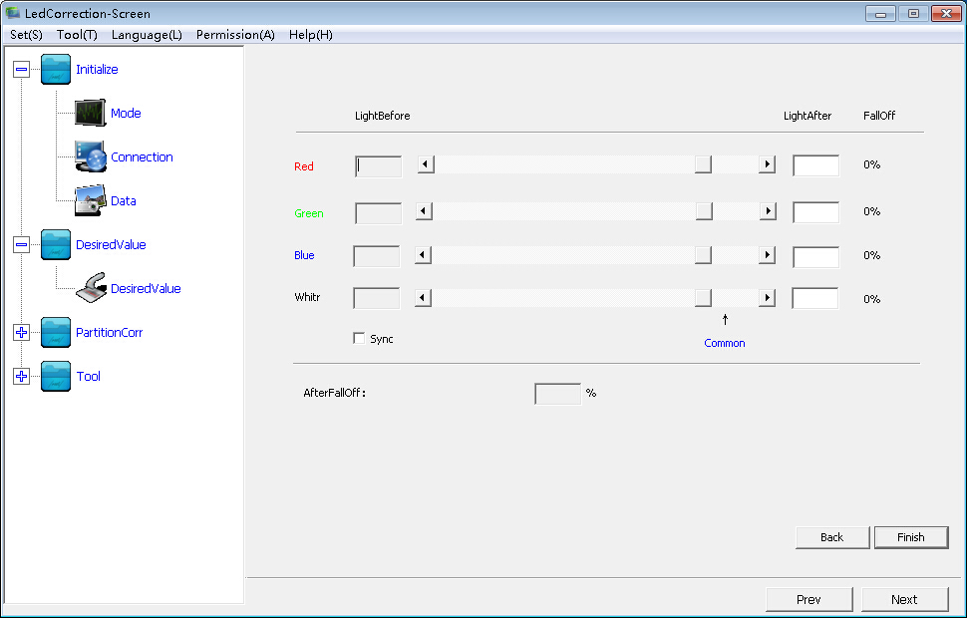
3.Partition calibration
1, Partition : A, regular partition , set partition size by clicking”next”
B,

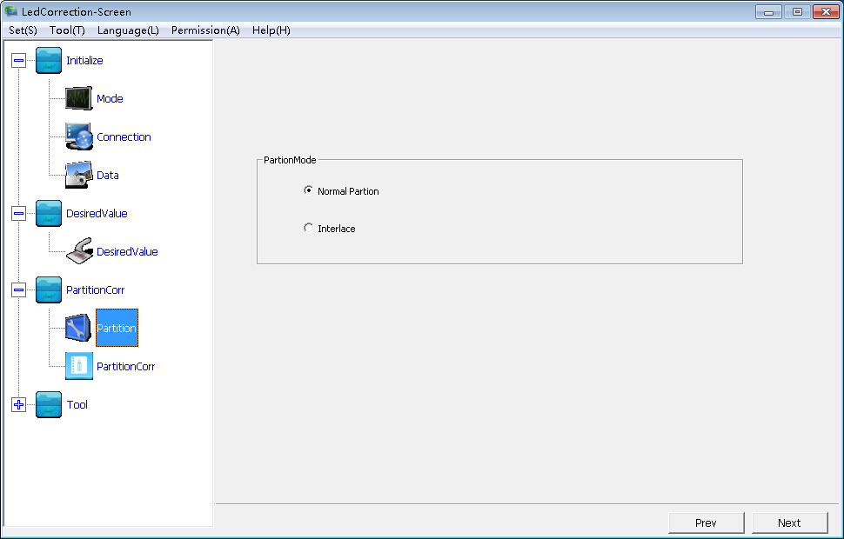

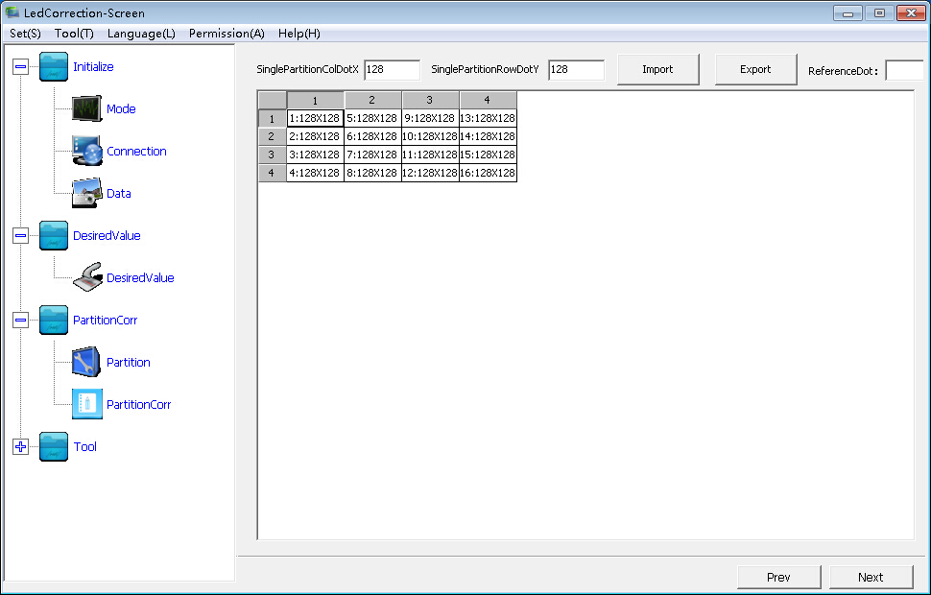
2, Partition calibration
A, Data acquisition : come into the data acquisition interface
B,Save to the hardware : save the data to the receiving card
C,Save to file : save calibration data to a local file (RVS)

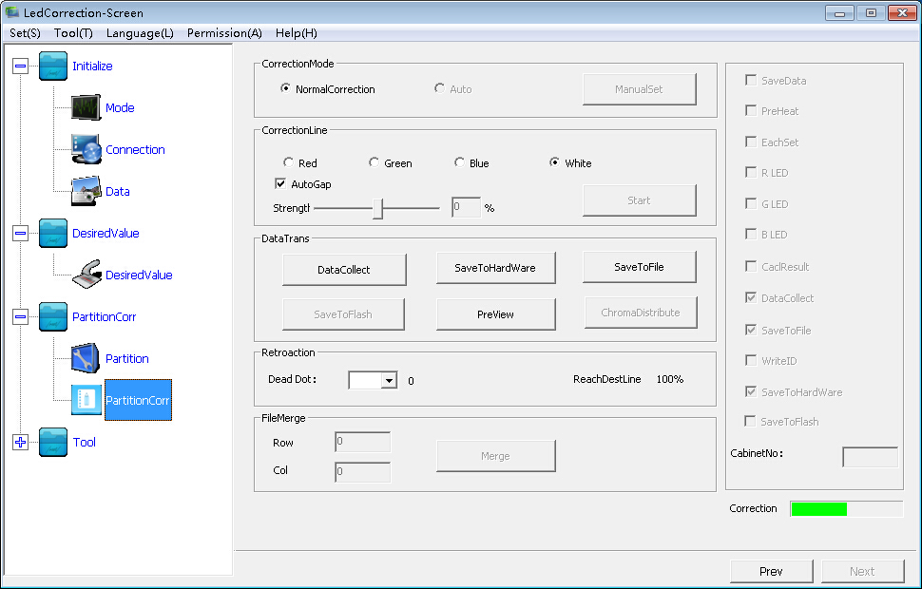

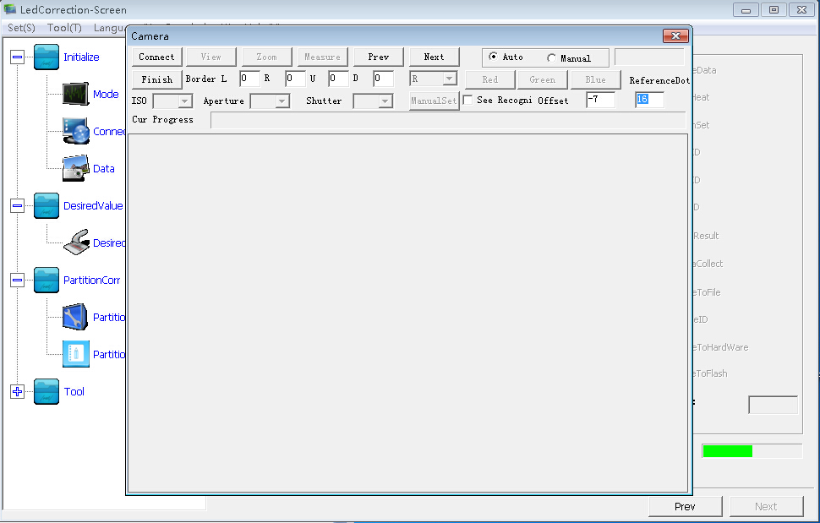
A - 1, camera connection: software connect to the camera
A - 2,preview : preview window shows the camera collected pixels
A - 3,zoom: magnify image (under the manual focus mode)
A - 4,measuring: control the camera to calibration by software
A - 5,”last and next” : last zone and next zone
A - 6,save: save calibration data to the receiving card
A - 7,reference dots: the discrepancy light dots between partitions (used to eliminate the differences between partitions)
A - 8,border dots: removal the pixels which blocked by the edges of the screen
A - 9,effect: view the effect after calibration

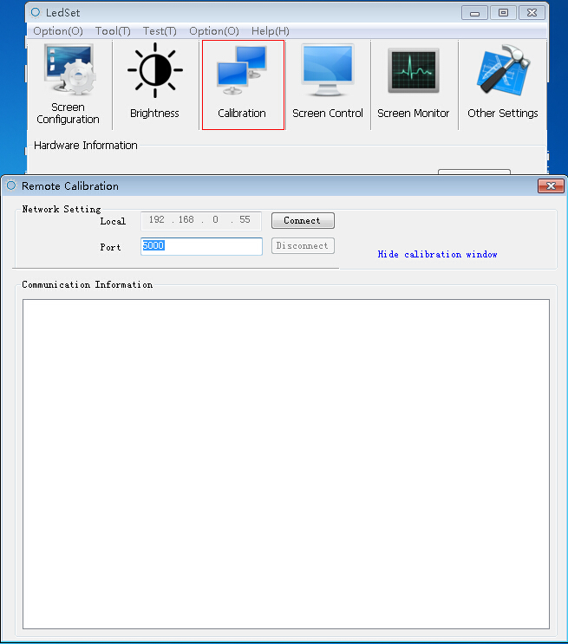
2,Online control
A, Local calibration : standalone calibration , need to keep the parameter( COM port, frequency, resolution) same as the setting of sending card .
B,Online calibration: two computers connected to the internet , the first computer connected to the screen , the second computer controlled the first computer to calibration by internet
Otherwise, online calibration need to work with Ledset.(download link:http//:www.linsn.com)

